About the Excel Workbooks

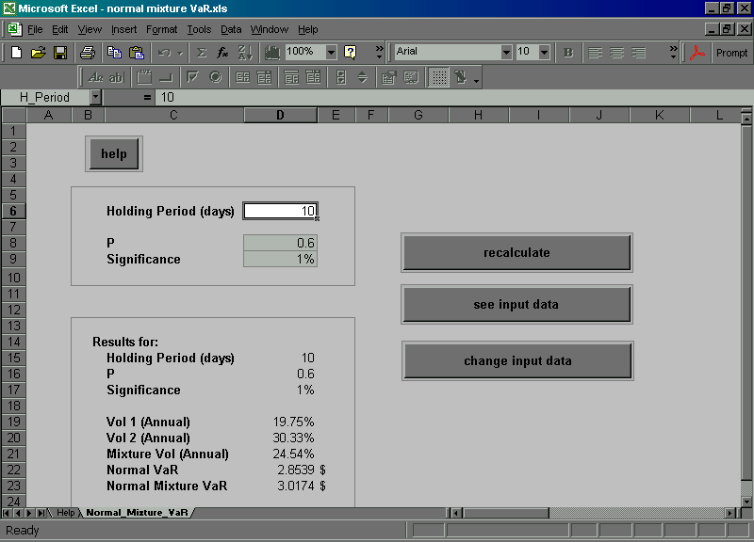

These workbooks have been written to supplement the exercises and illustrations already given in the text. They have been protected by password and readers can obtain this by registering on the website for the book: www.wiley.co.uk/marketmodels. As well as using the workbooks to build their own examples, based on data used in the book, the interested reader may like to view the hidden sheets (where explanatory calculations are given) and the VBA code. Each workbook contains a Help sheet that explains the usage, with copious references to relevant parts of the text.

The reader is kindly requested to read and respect the important copyright information given with this CD. As stated in the copyright information, these programs are provided for educational purposes only; they are not guaranteed in any way to any user and neither the authors nor Wiley have any responsibility of any sort. Please read the copyright document for further details.

Modifications, extensions and new developments to these programs will, hopefully, be taking place via the user discussion forum on the www.wiley.co.uk/marketmodels website.

